**USER GUIDE**



**Aptech Computer Learning Center** D - 4 Block H North Nazimabad Town

Karachi, Karachi City, Sindh 74700, **Call:** +922136620102,

**Email:** [http://aptech-education.com.pk/locateus.html?cid=2086\](http://aptech-education.com.pk/locateus.html?cid=2086)

information:

|  |  |  |  |  |
| --- | --- | --- | --- | --- |
| student  name | hamza  rashid | sameer  shams | IRTIZA JAVED | AHTISHAM |
| ENROLLMENT  NO | 1279909 | 1278932 | 1279913 | 1283660 |
| FACULTY  NAME | MISS ANUSHEH NAWAZI | | | |

***Submitted the eProject to:***

**Email Id:**[***eProjects@aglsm.com***](mailto:eProjects@aglsm.com)



ACKNOWLEDGMENT

We would like to express our special thanks to our teacher

(Miss Anusheh Nawazi) as well as our institute (Aptech) who gave us golden opportunity to do this wonderful project on this topic (Rainwater Harvesting), which also helped us a lot of research and we came to know about so many new things we are thankful to them.

Secondly, we would also like to thank our coordinator

(Miss Zehra Khan) and friends who have helped us a lot in finalizing this project within the limited time frame



**INTODUCTION**

**The thirst for learning, upgrading technical skills and applying the concepts in real life environment at a fast pace is what the industry demands from IT professionals today. However busy work schedules, far-flung locations, unavailability of convenient time-slots pose as major barriers when it comes to applying the concepts into realism. And hence the need to look out for alternative means of implementation in the form of laddered approach.**

**The above truly pose as constraints especially for our students too! With their busy schedules, it is indeed difficult for our students to keep up with the genuine and constant need for integrated application which can be seen live especially so in the field of IT education where technology can change on the spur of a moment. *Well, technology does come to our rescue at such times!!***

**Keeping the above in mind and in tune with our constant endeavour to use Technology in our training model, we at Aptech have thought of revolutionizing the way our students learn and implement the concepts using tools themselves by providing a *live and synchronous eProject learning environment!* **

****SITE MAP





**PRE LODING**





**HOME PAGE:**







**Navigation**











****CONTACT US

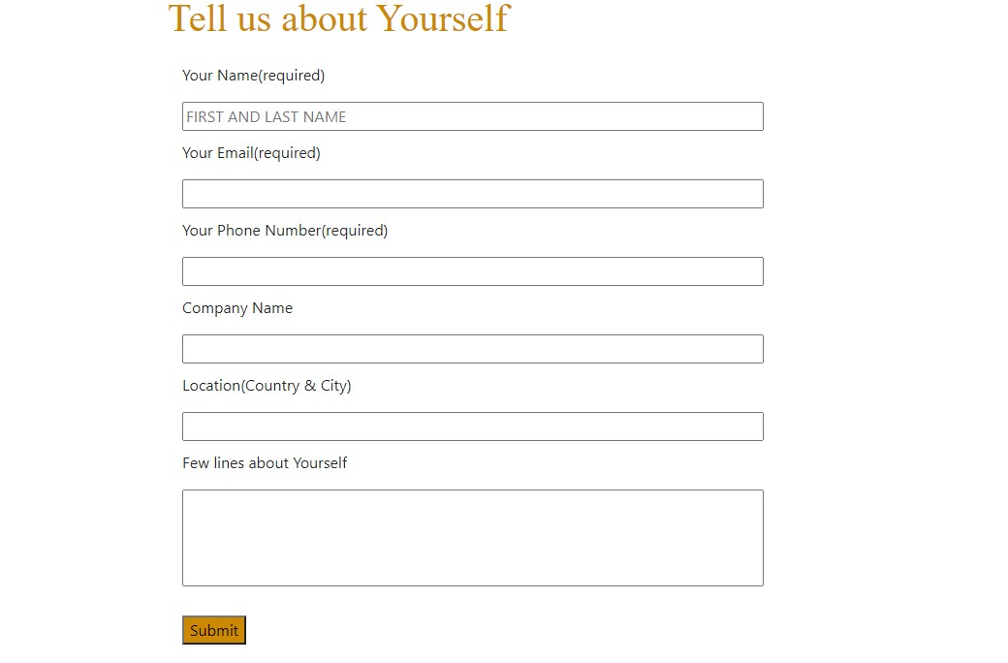

****CERTIFICATION

OF COMPLETION

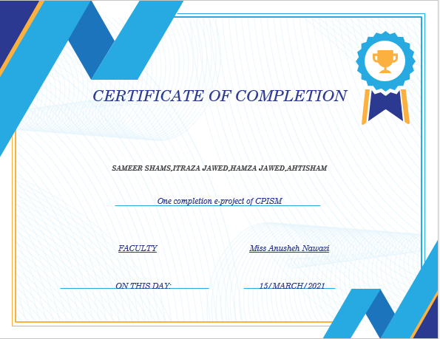

****FOOTER





FROM OUR TEAM MEMBERS

HAMZA RASHID

IRTIZA JAVED

AHTISHAM

SAMEER SHAMS

